Project Report

**Hotel Management System**

**1.E-R Model of the Project**

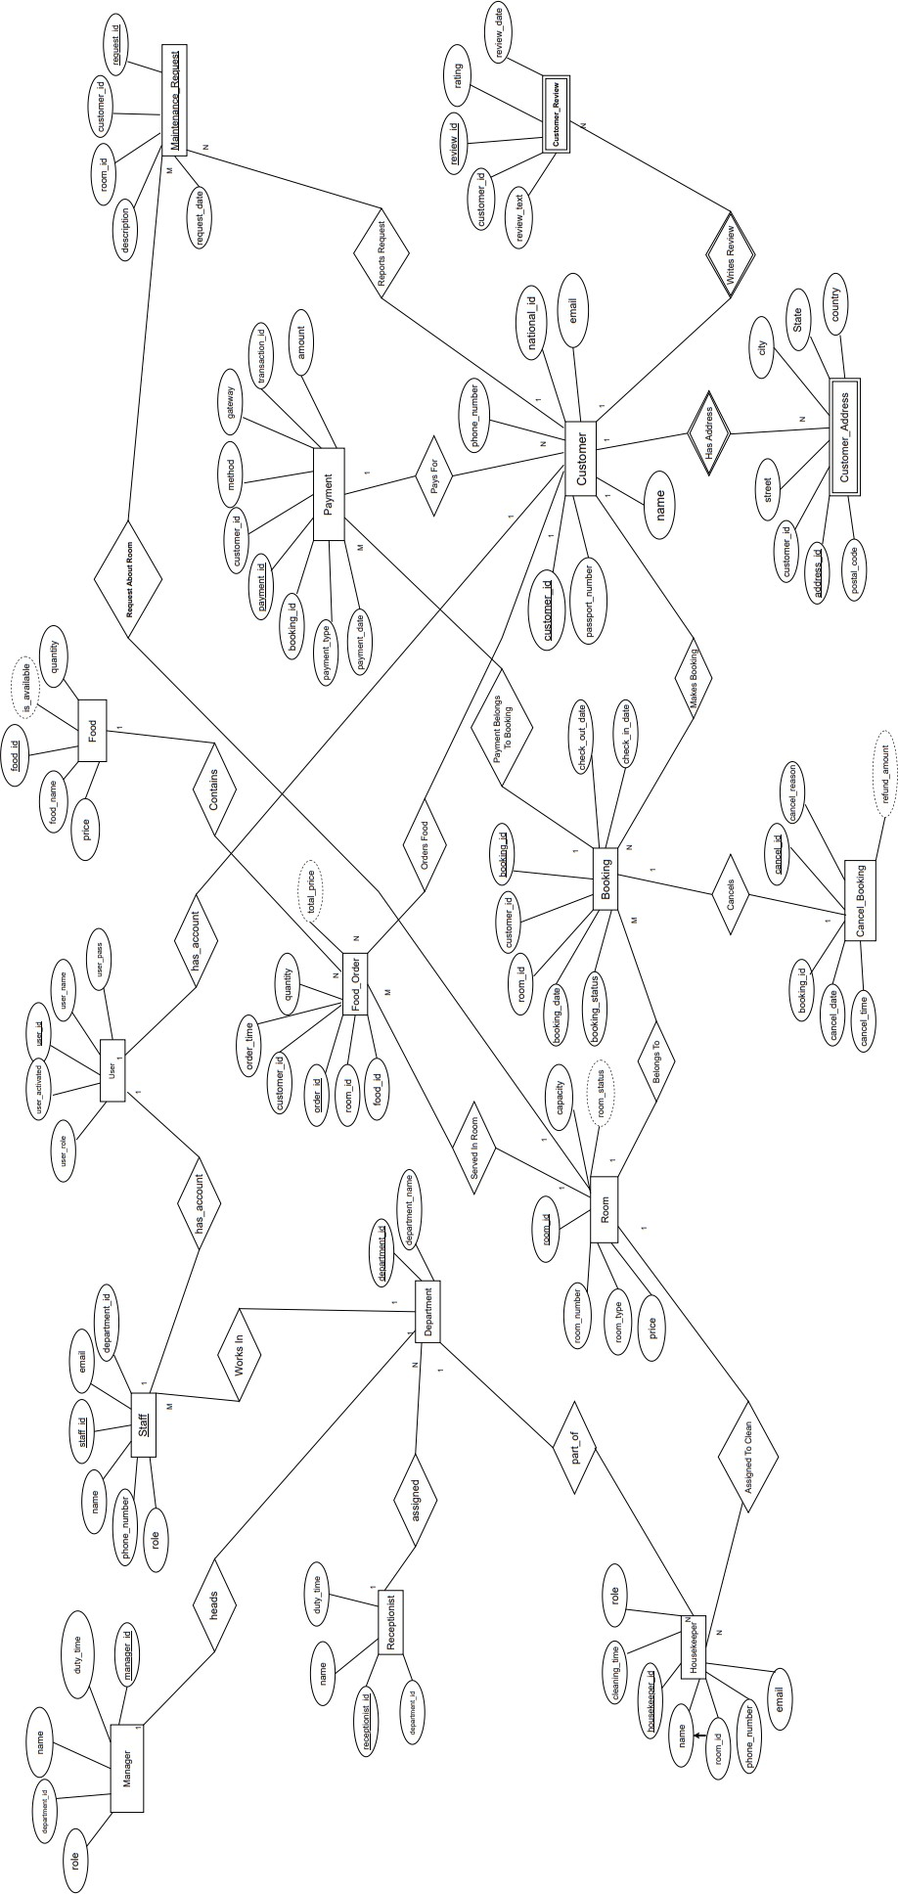

1. 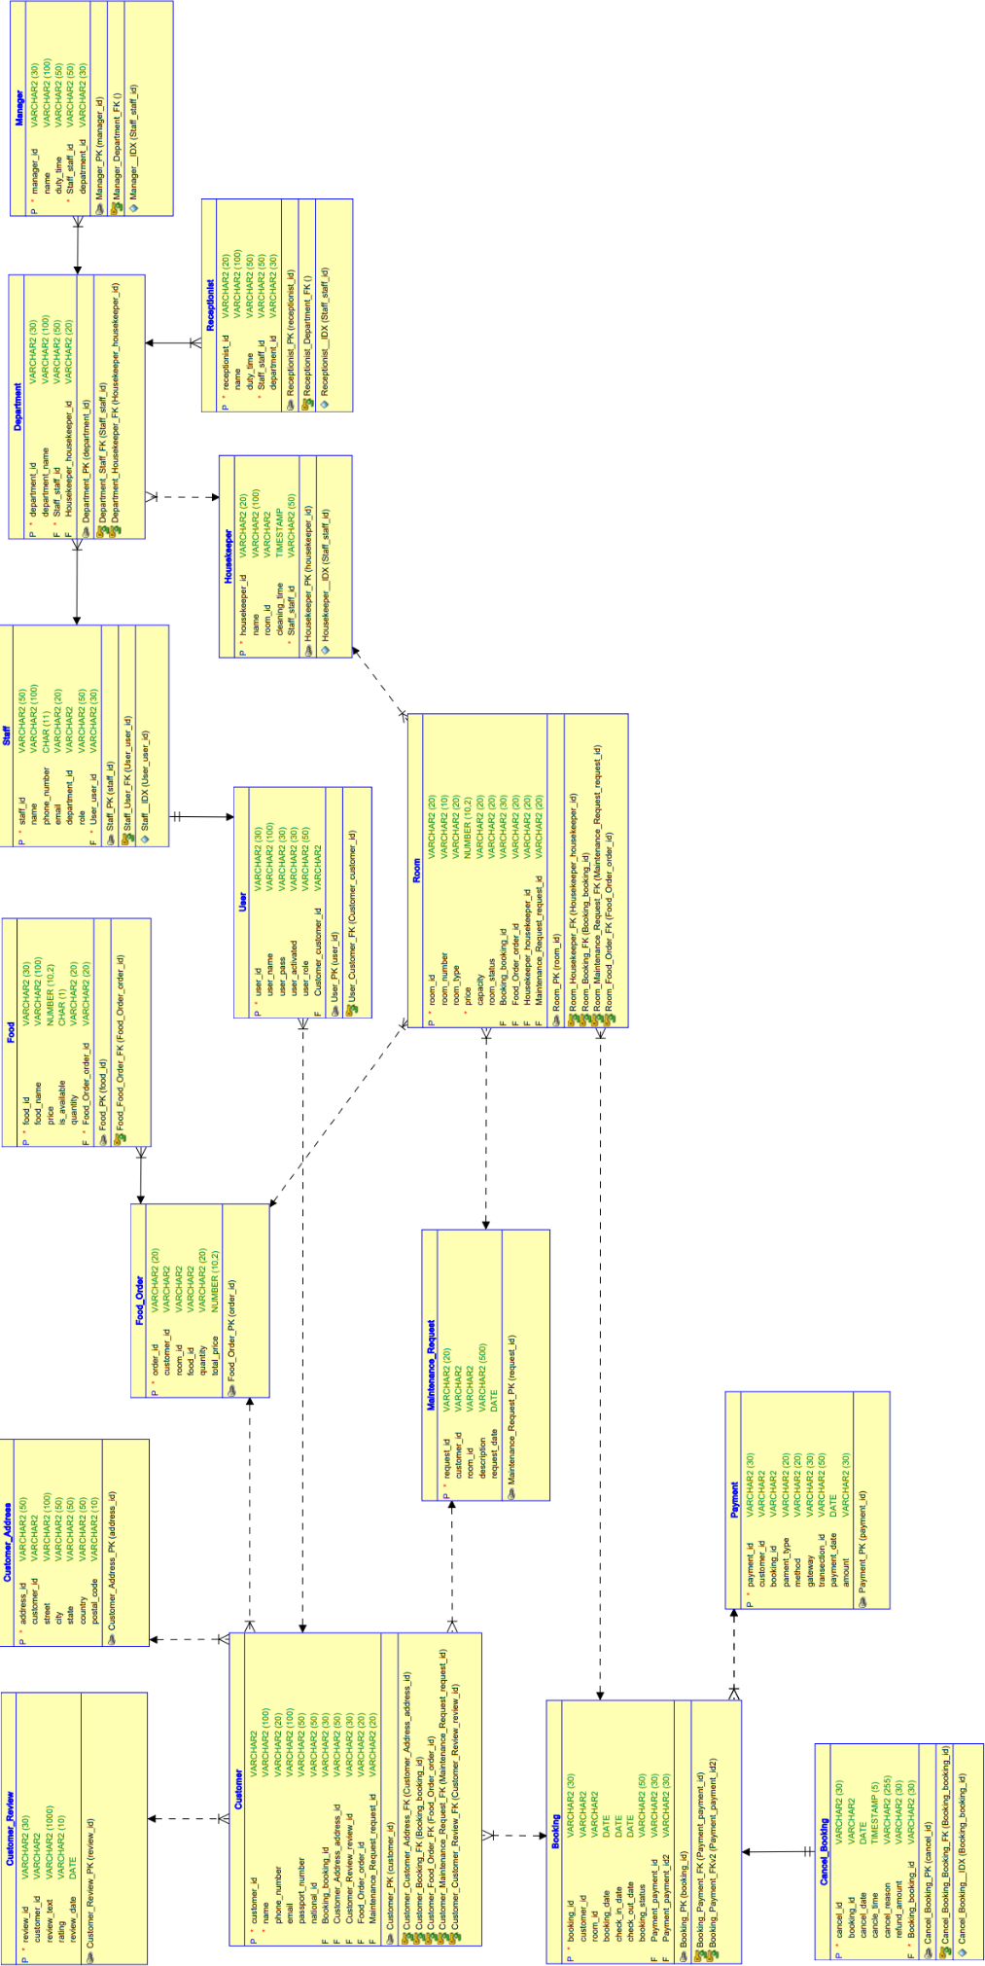**Schema Design of the Project**
2. **Reports with Forms**

|  |  |  |
| --- | --- | --- |
| **Report Page Number and Name** | **Form Page Number and Name** | **Table** |
| Page 3-Customer Details | Page 2- Customer Form | Customer |
| Page 6 - Customer Address Details | Page 5 - Customer Address Form | Customer address |
| Page 9 - Room Details | Page 8 - Room Form | Room |
| Page 12 - Booking Details | Page 11 - Booking Form | Booking |
| Page 15 - Food Details | Page 14 - Food Form | Food |
| Page 18 - Food Order Details | Page 17 - Food Order Form | Food Order |
| Page 21 - Housekeeper Details | Page 20 - Housekeeper Form | Housekeeper |
| Page 24 - Maintenance Request Details | Page 23 - Maintenance Request Form | Maintenance Request |
| Page 27 - Manager Details | Page 26 - Manager Form | Manager |
| Page 30 - Receptionist Details | Page 29 - Receptionist Form | Receptionist |
| Page 33 - Department Details | Page 32 - Department Form | Department |
| Page 36 - Staff Details | Page 35 - Staff Form | Staff |
| Page 39 - Payment Details | Page 38 - Payment Form | Payment |
| Page 42 - Cancel Booking Details | Page 41 - Cancel Booking | Cancel Booking |
| Page 45 - Customer Review Details | Page 44 - Customer Review Form | Customer Review |
| Page 51 - User Details | Page 50 - User Form | User |

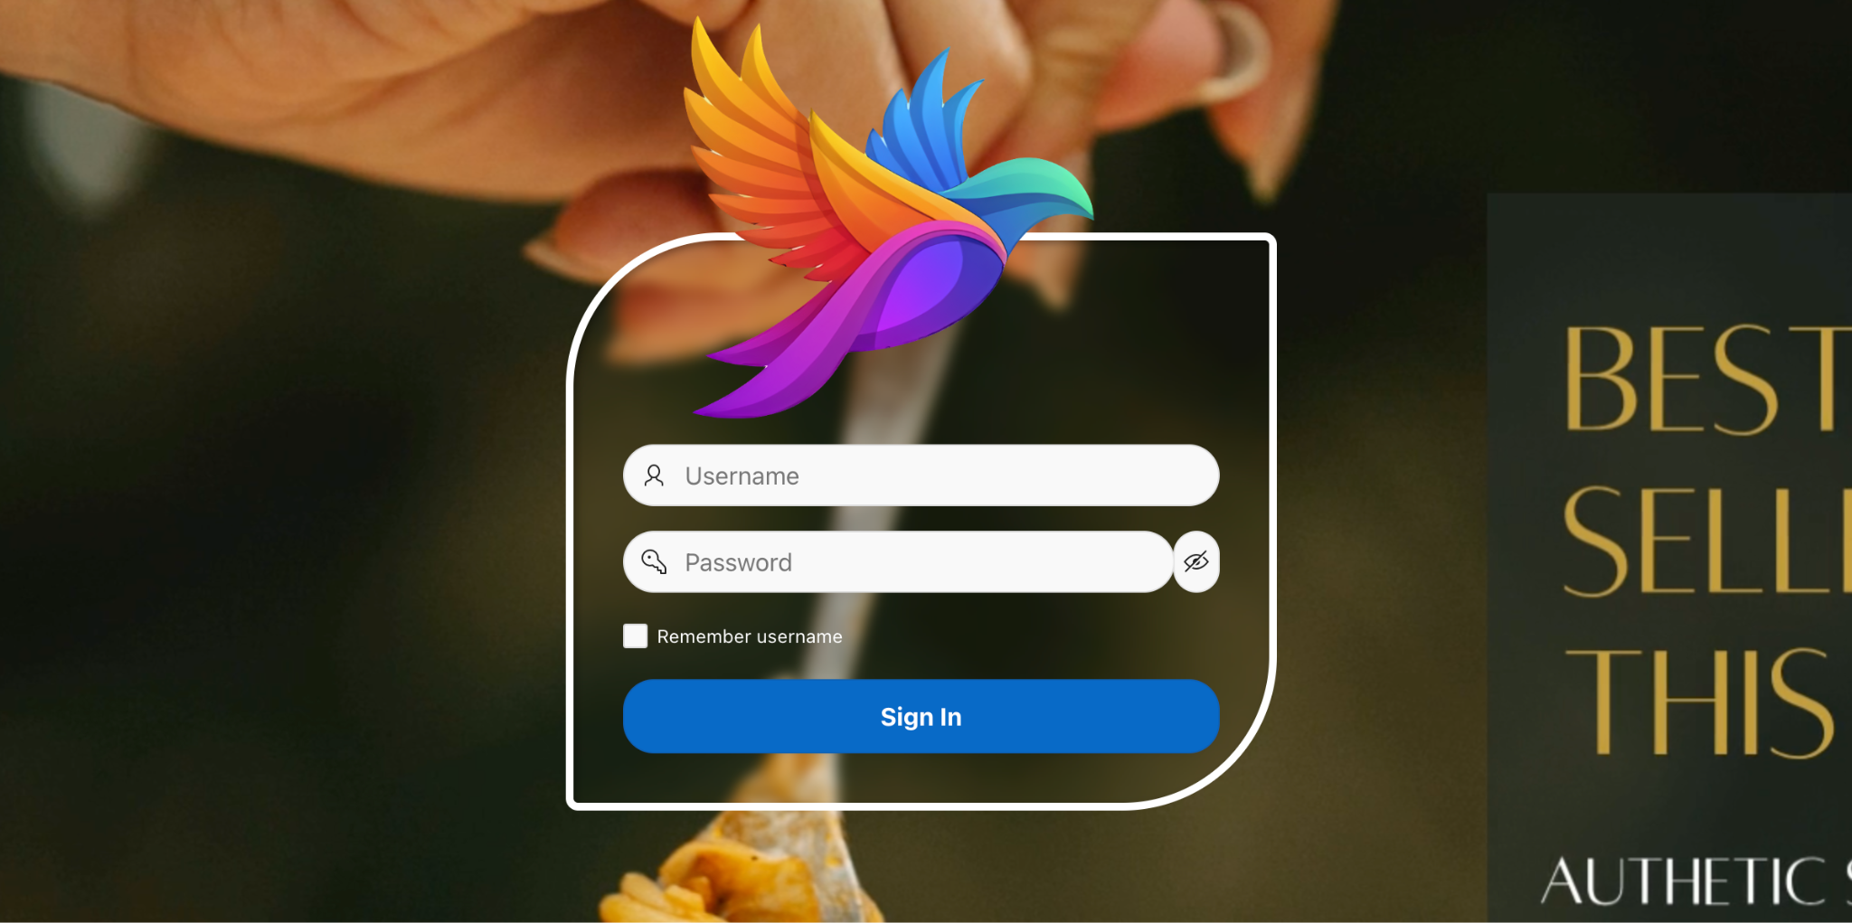

Login page

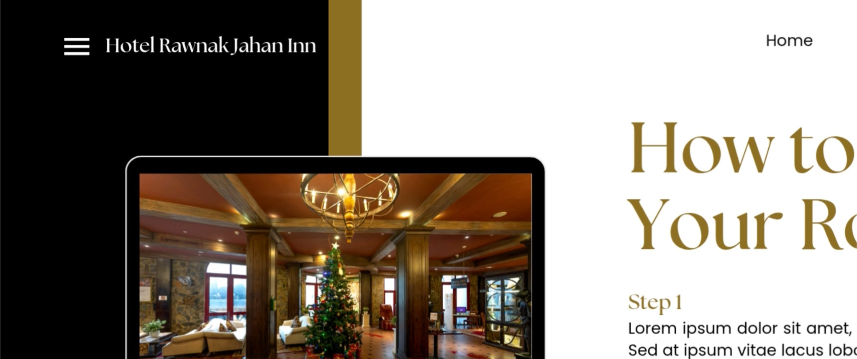

Home Page

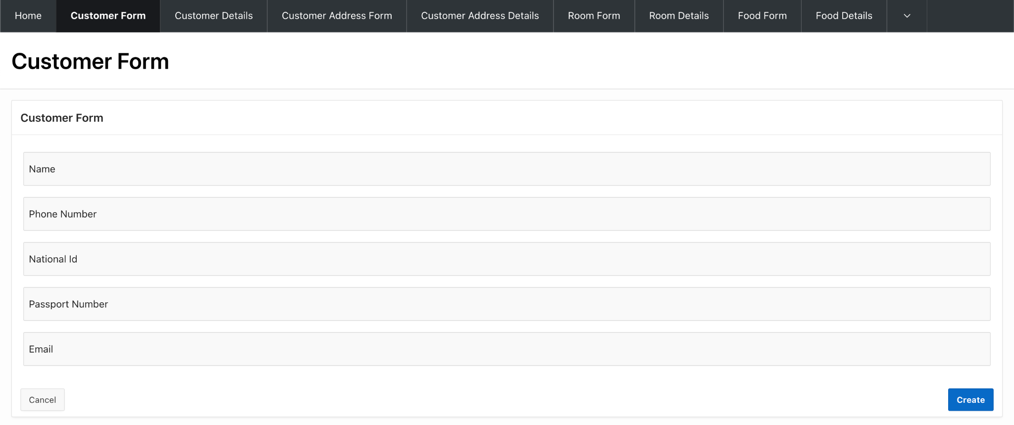

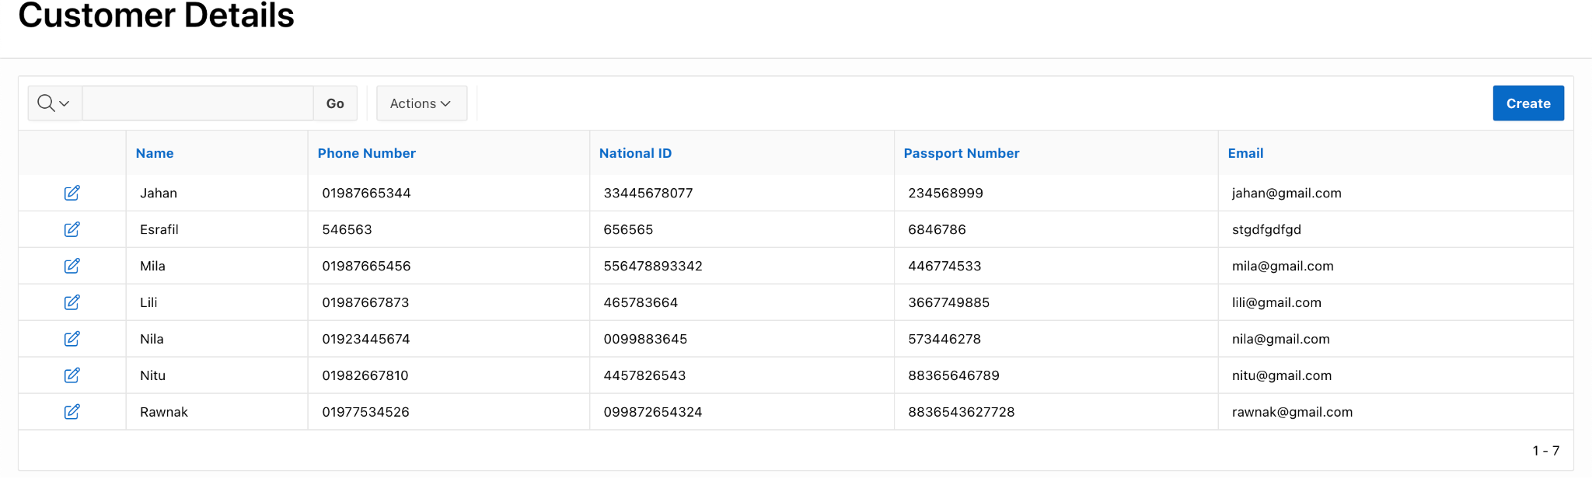

4.1- Customer Form & Details

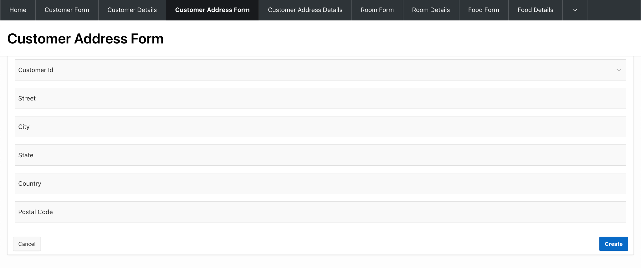

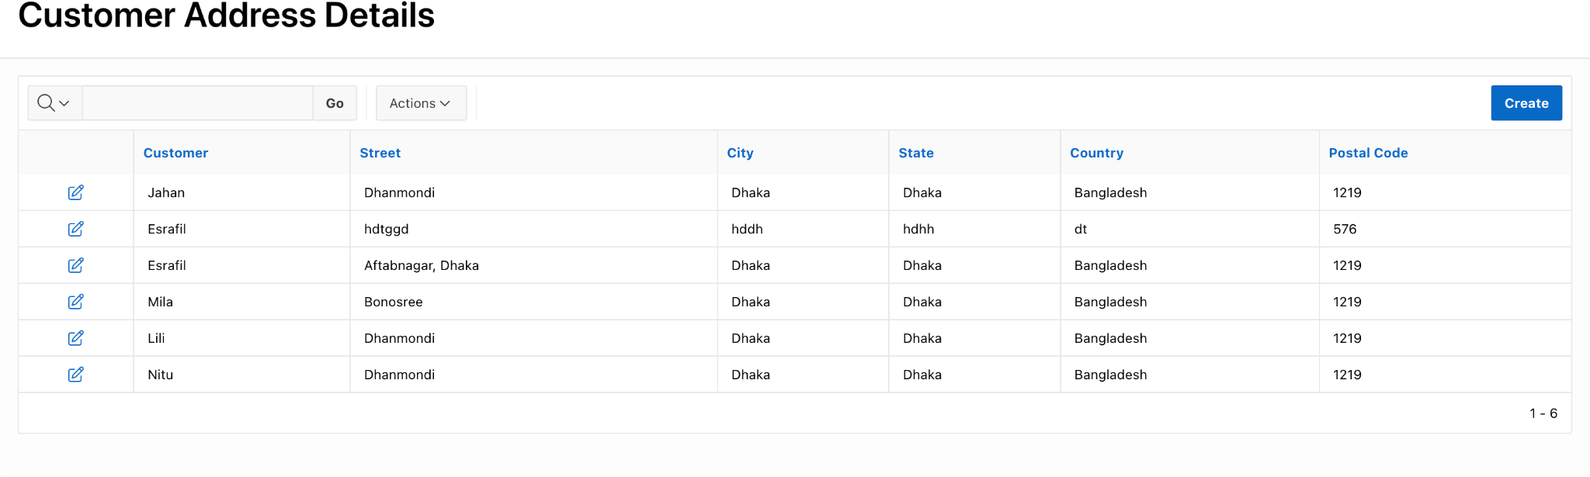

4.2- Customer Address Form & Details

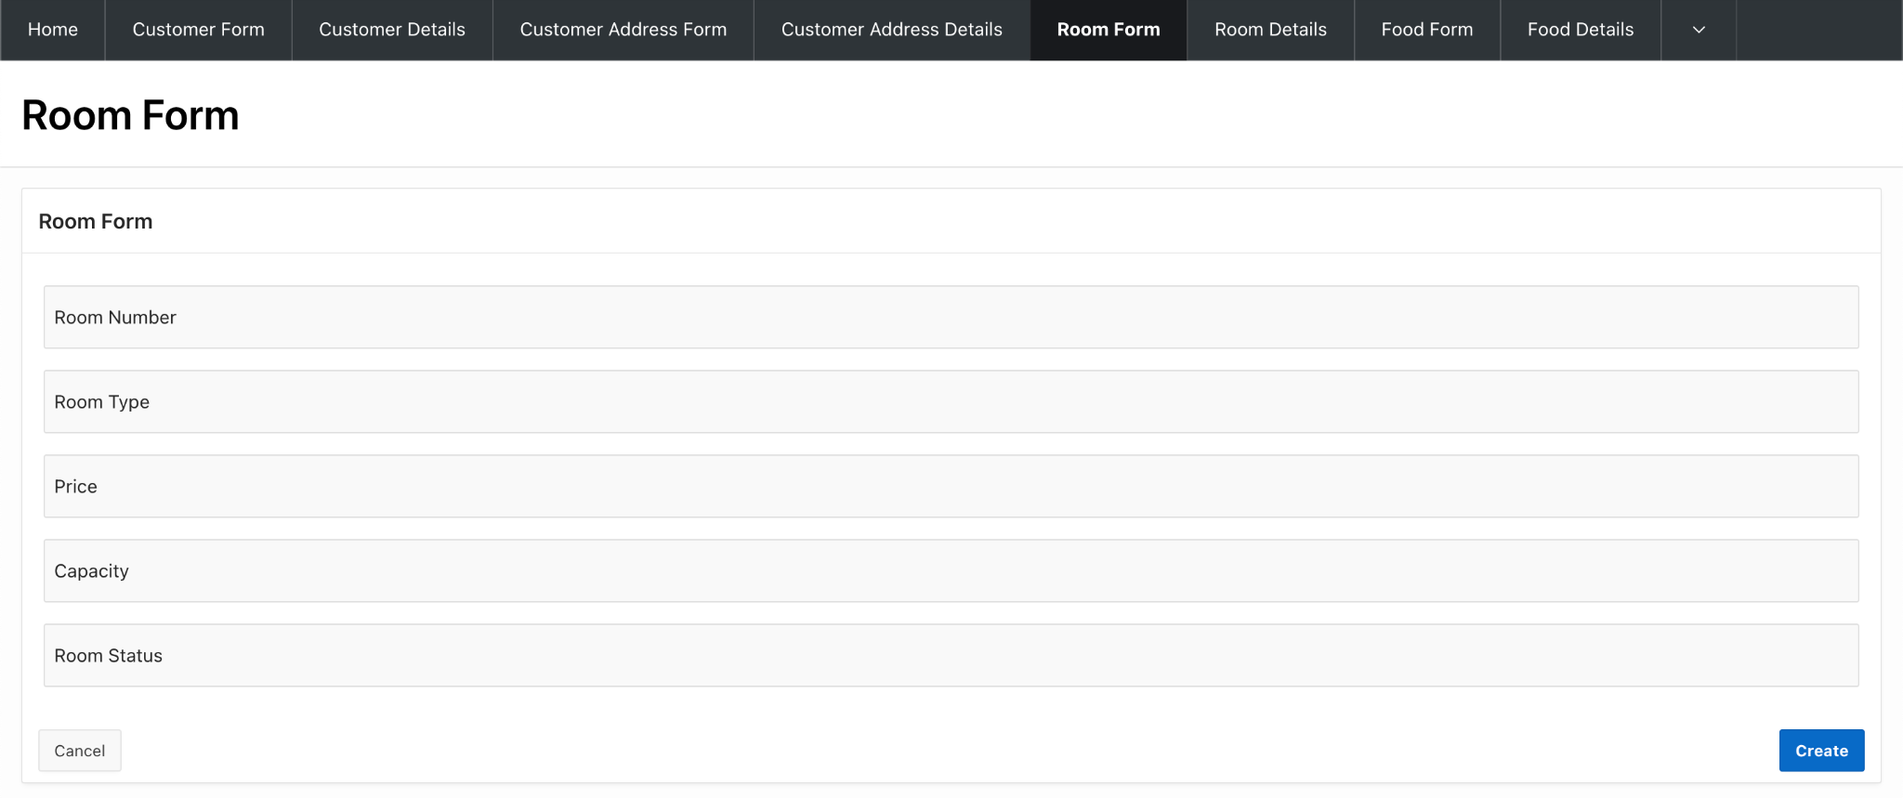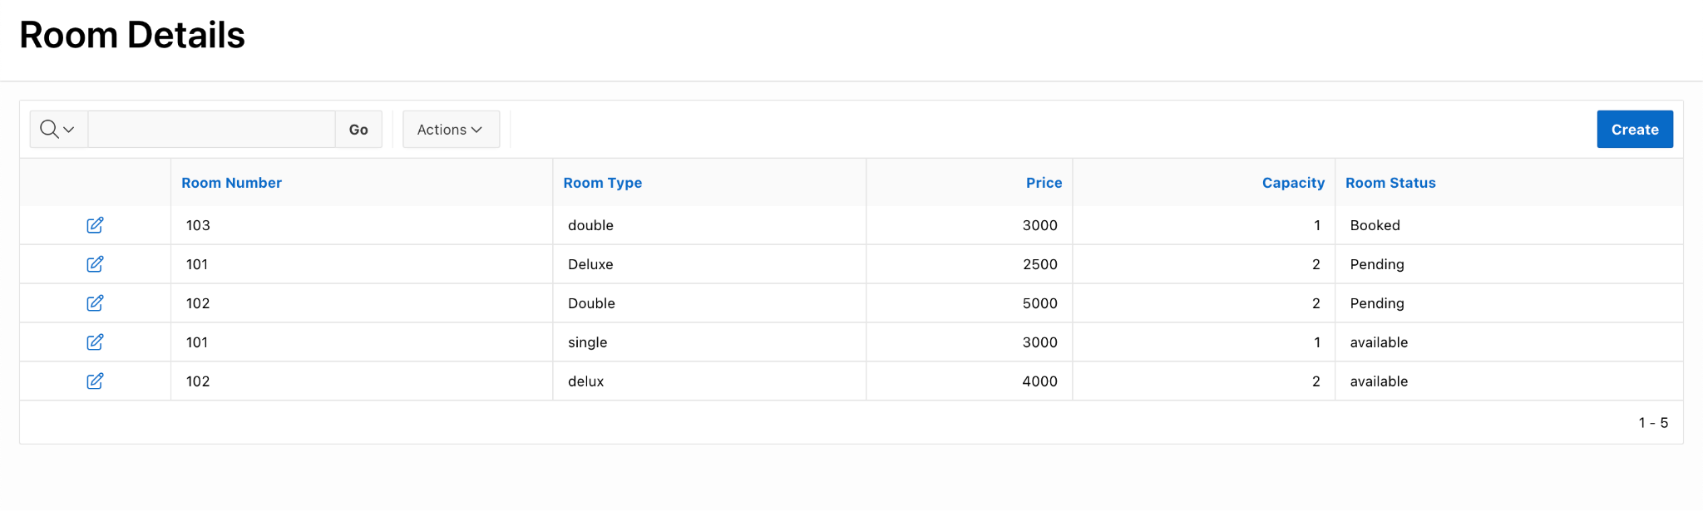

4.3- Room Form & Details

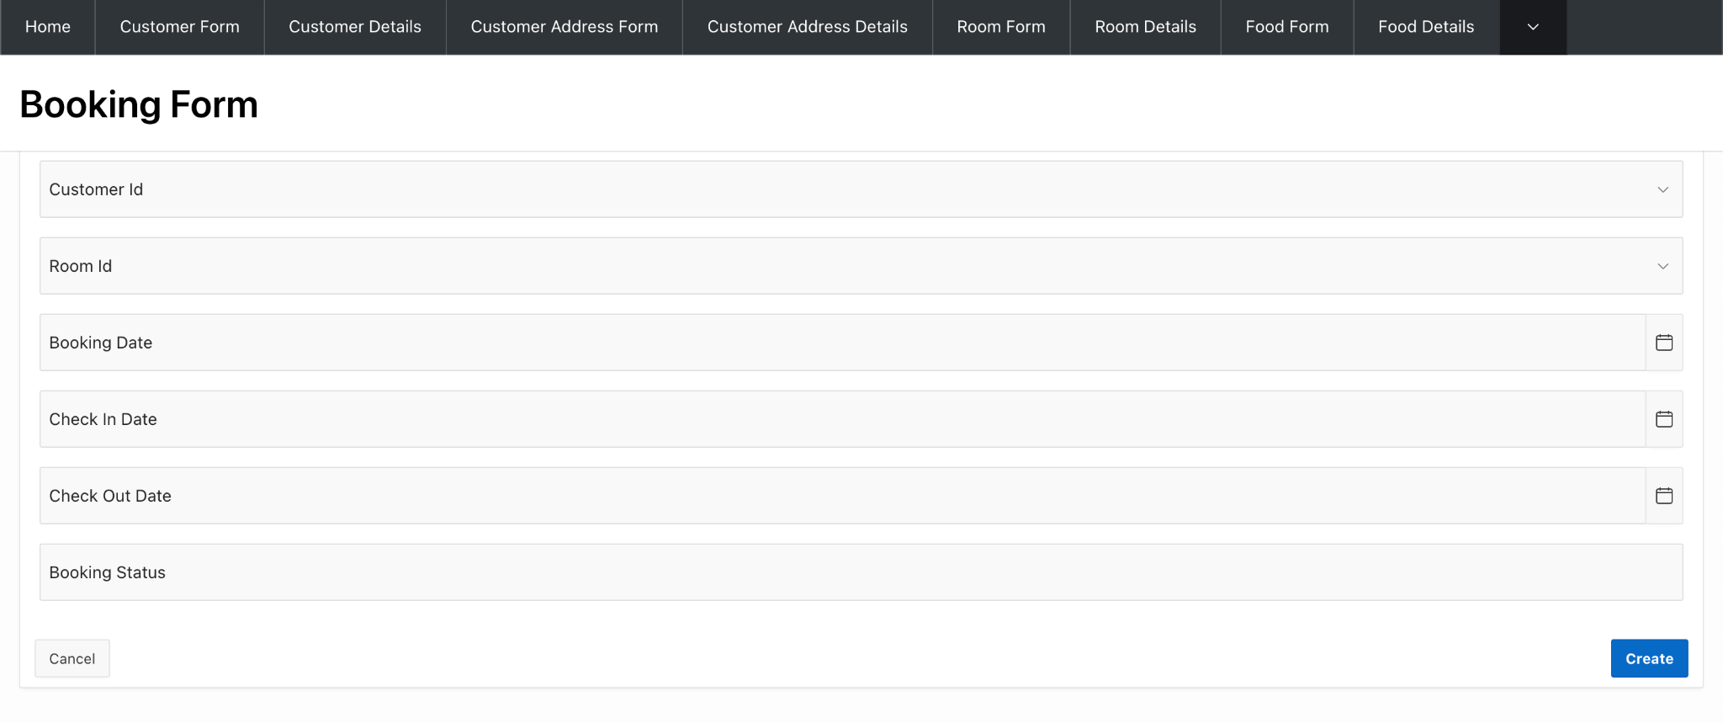

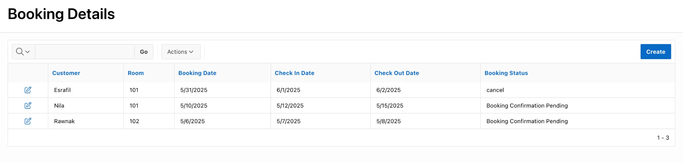

4.4- Booking Form & Details

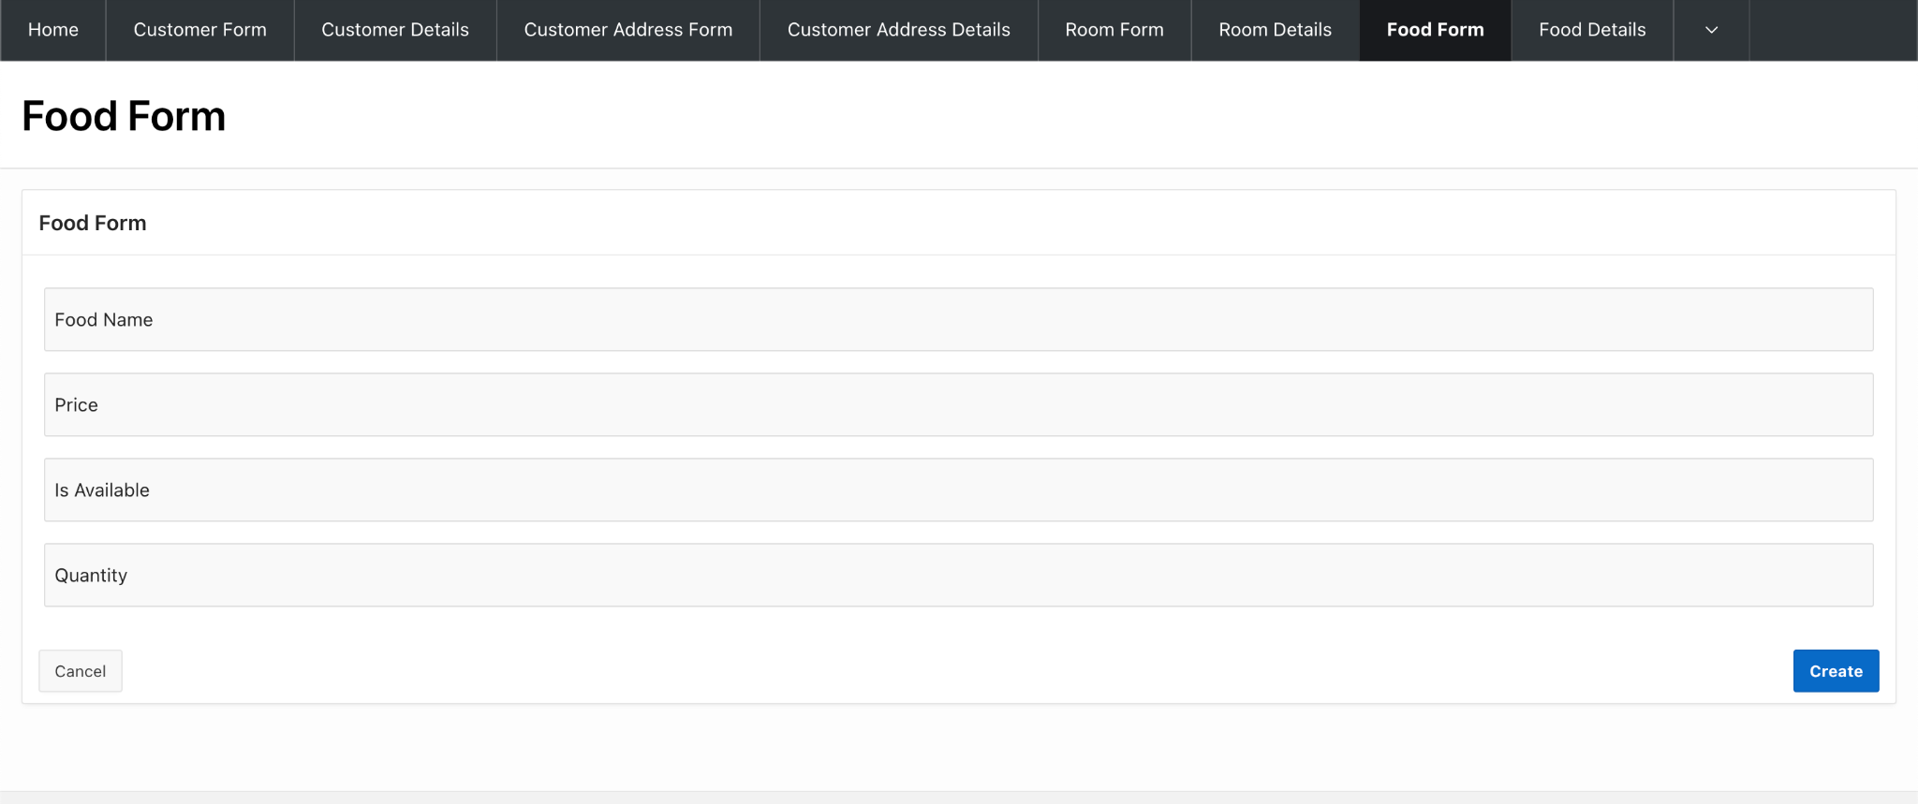

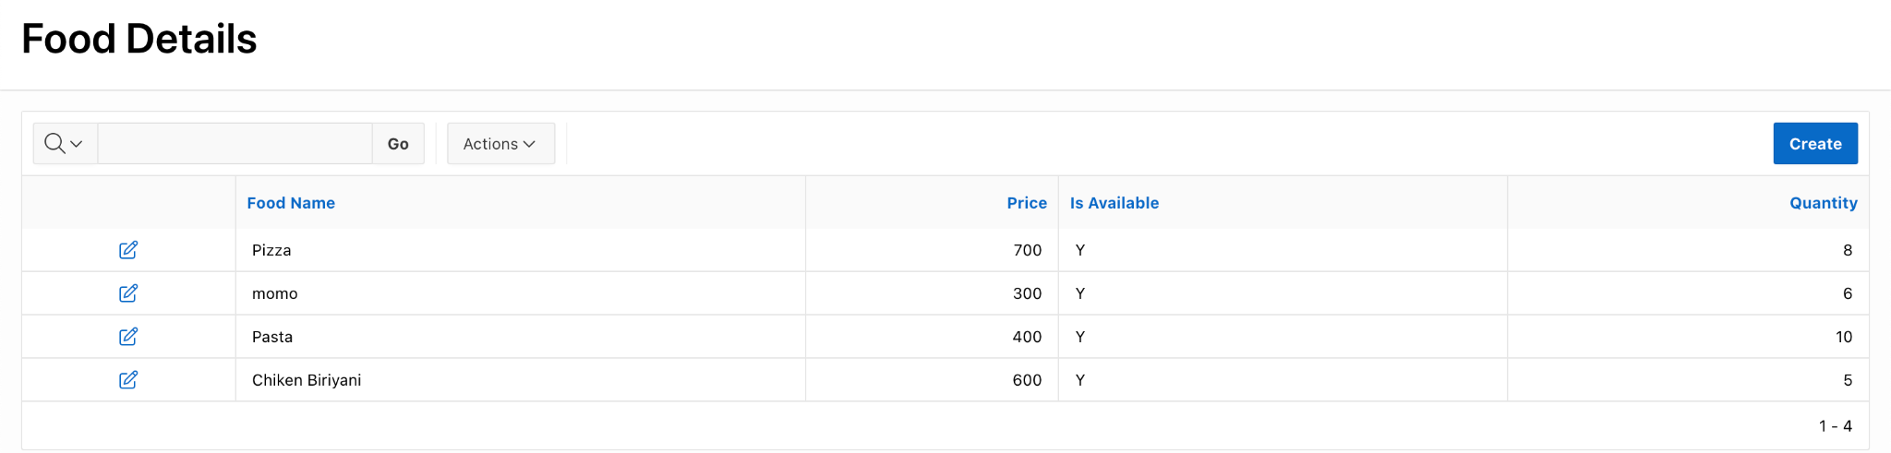

4.5- Food Form & Details

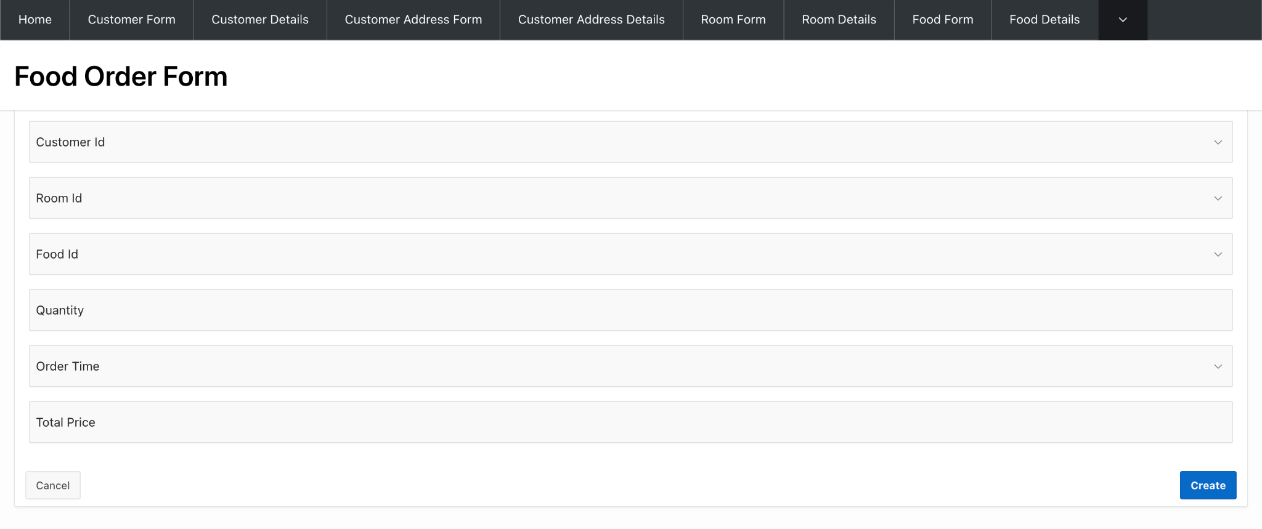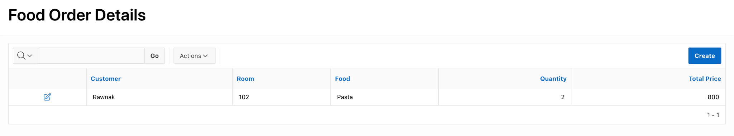

4.6- Food Order Form & Details

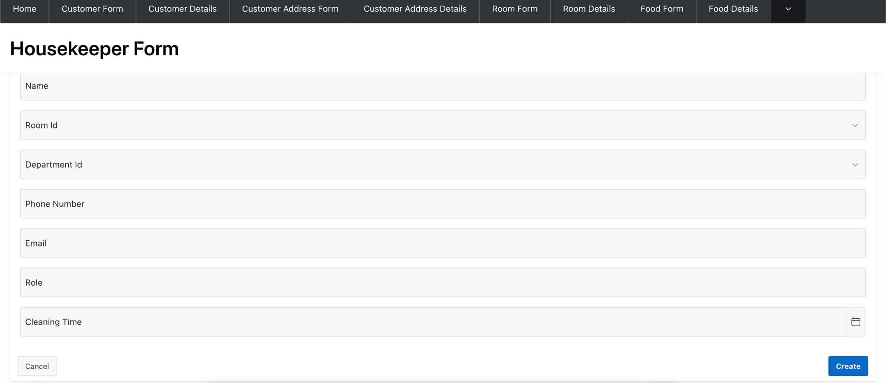

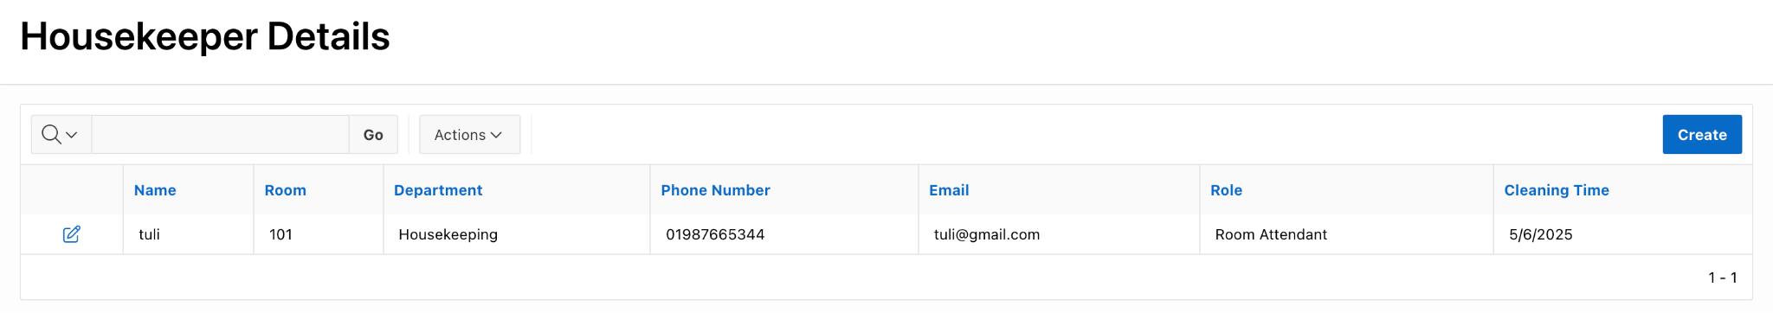

4.7- Housekeeper Form & Details

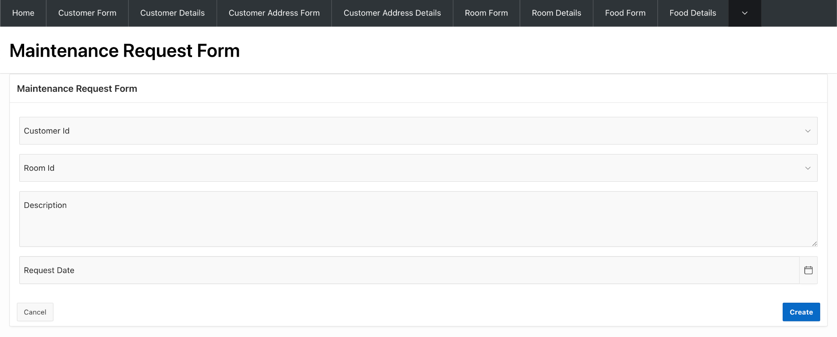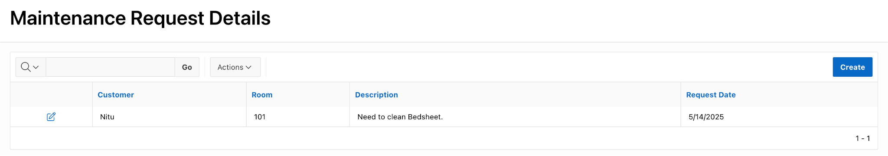

4.8- Maintenance Request Form & Details

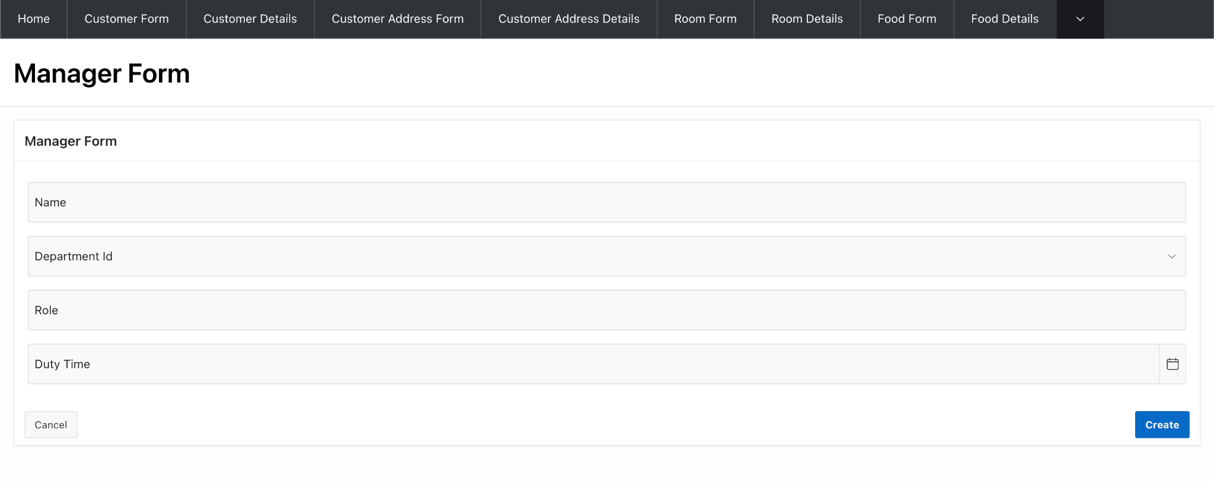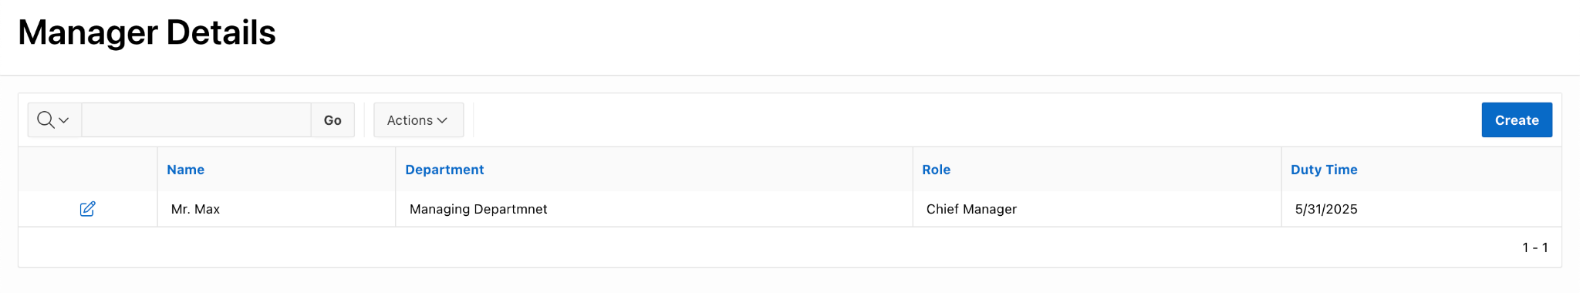

4.9- Manager Form

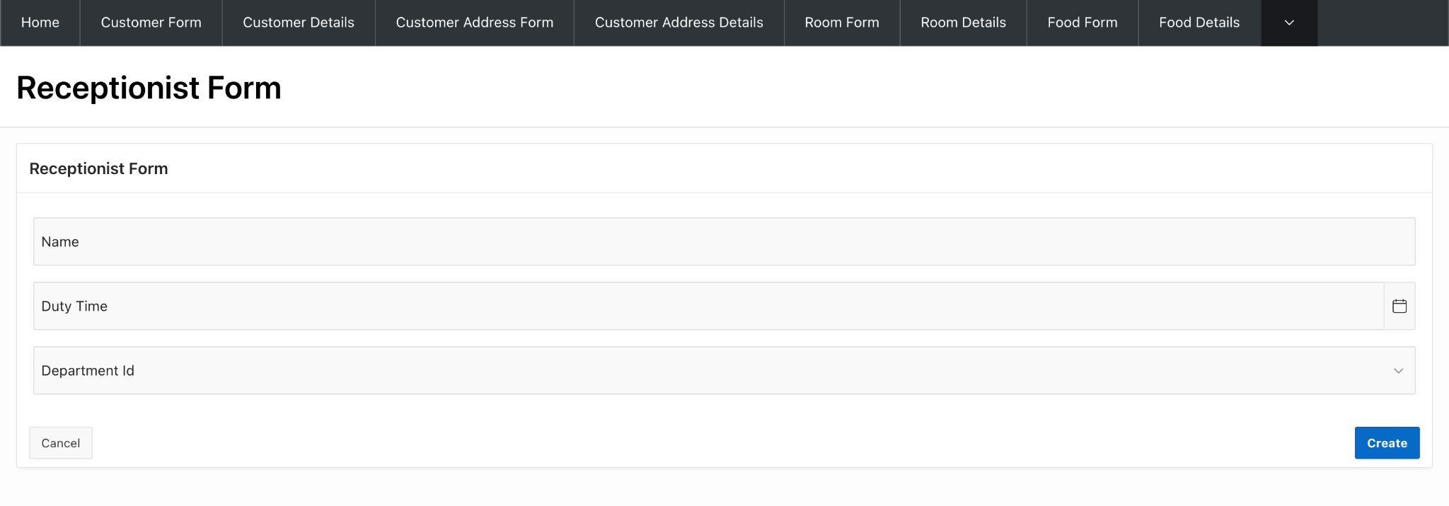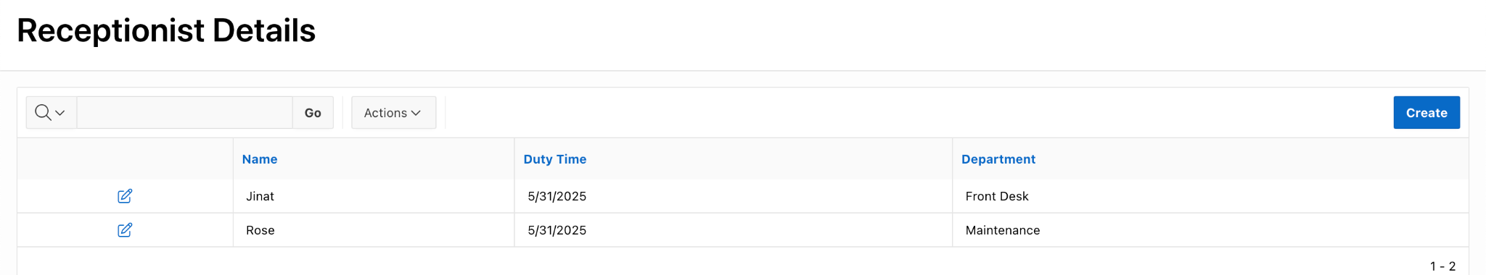

4.10 Receptionist Form & Details

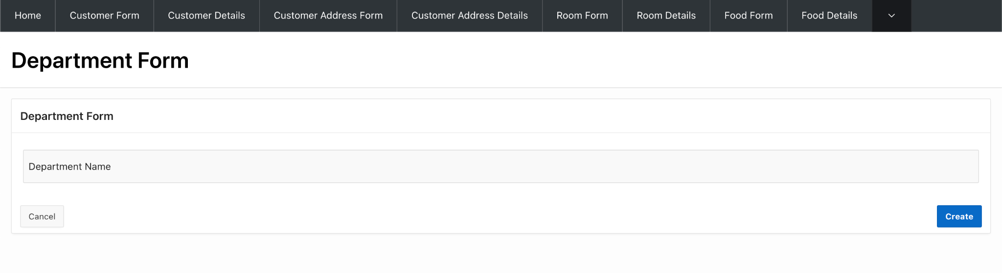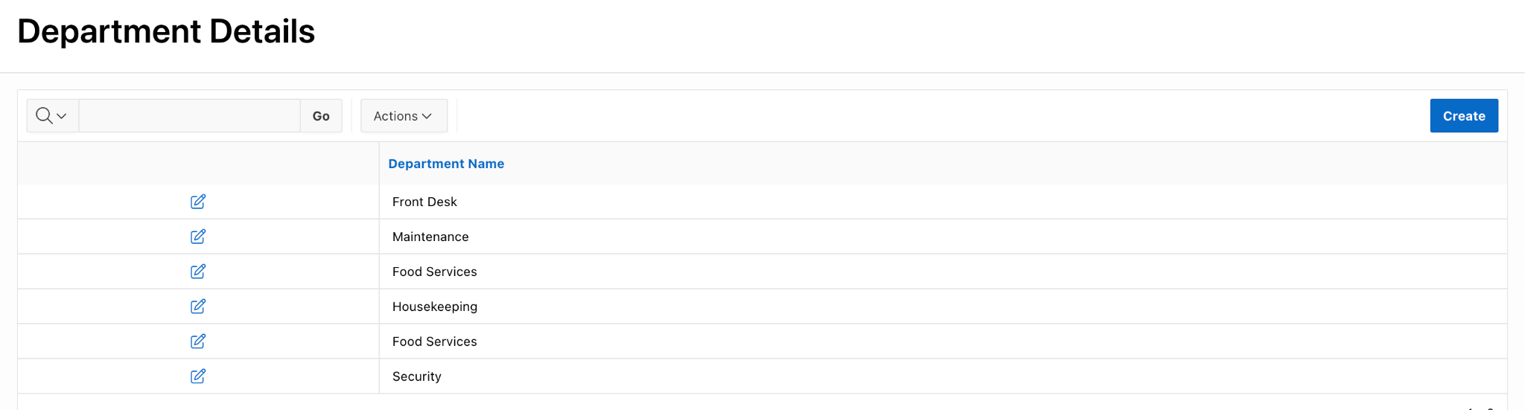

4.11- Department Form & Details

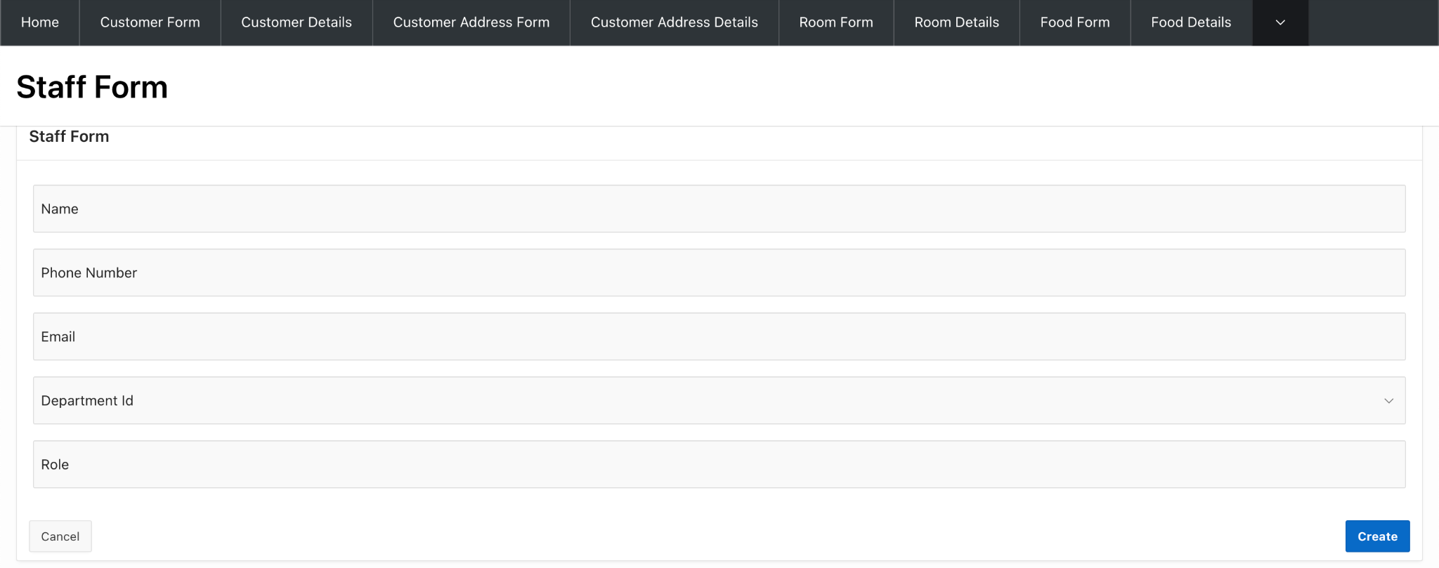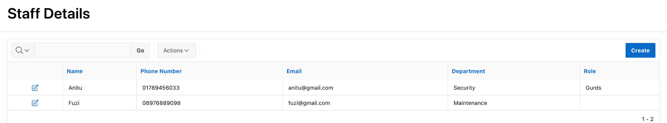

4.12- Staff Form & Details

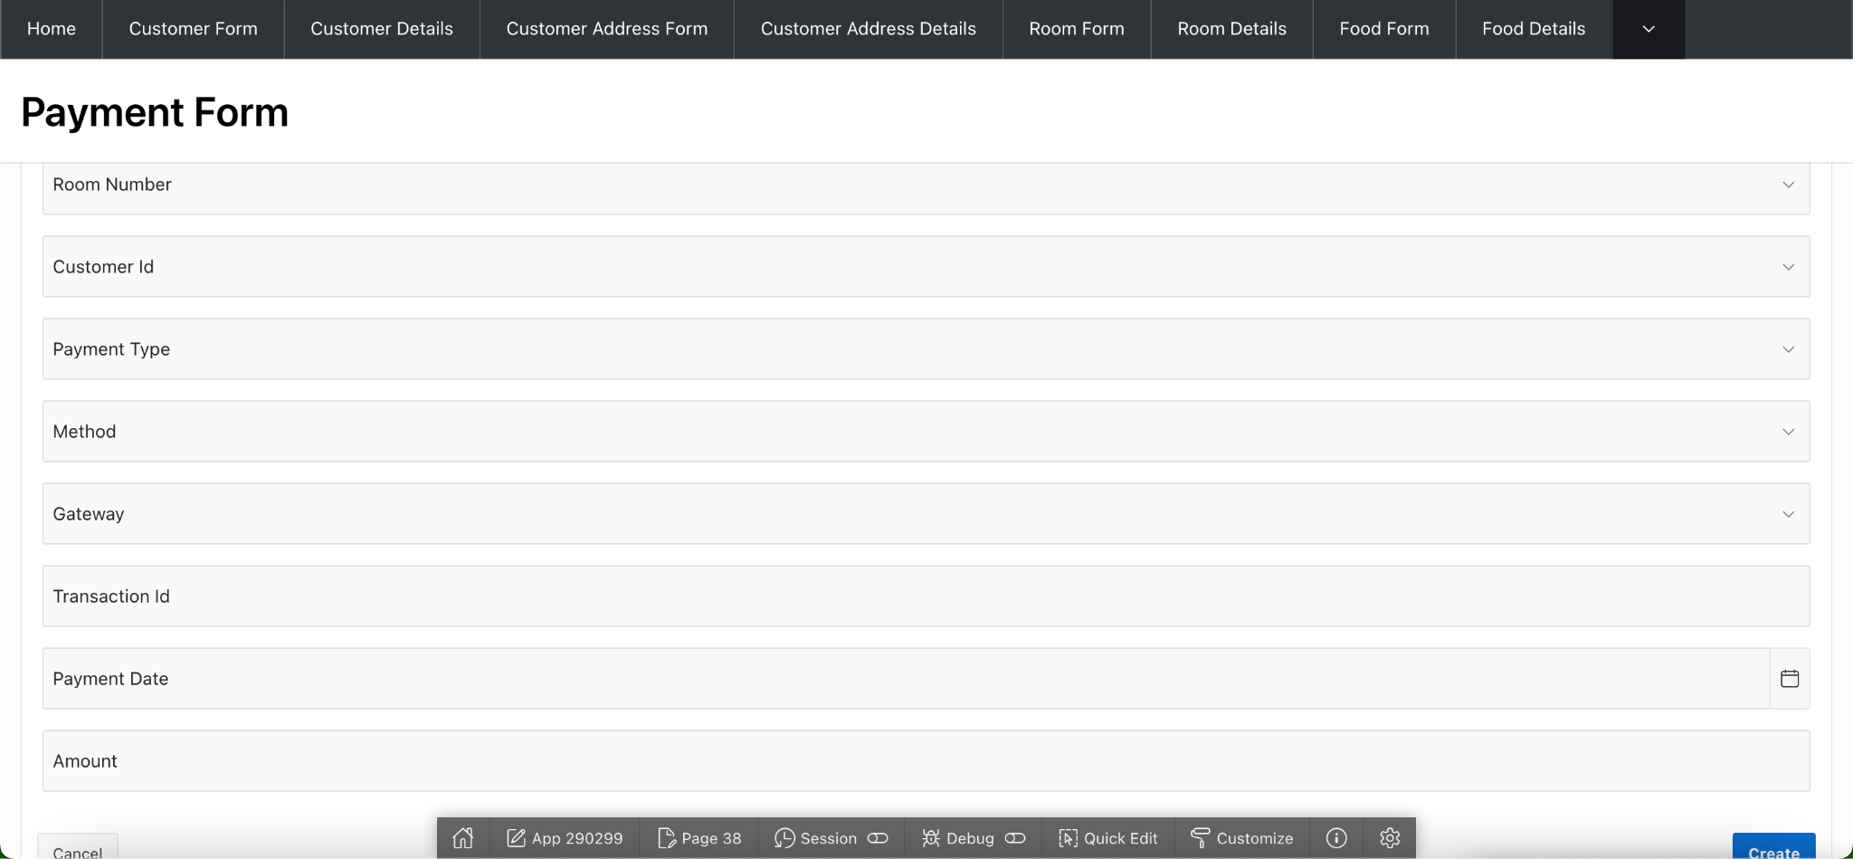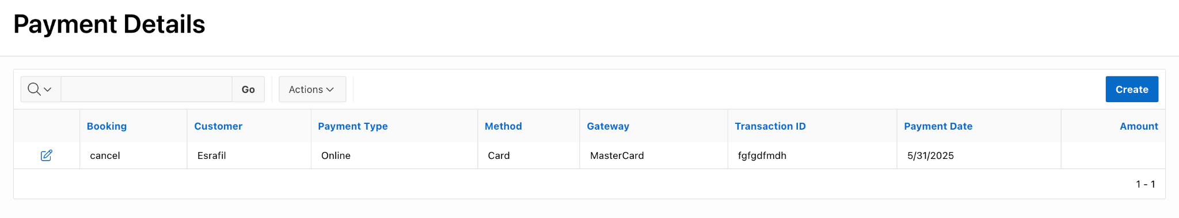

4.13- Payment Form & Details

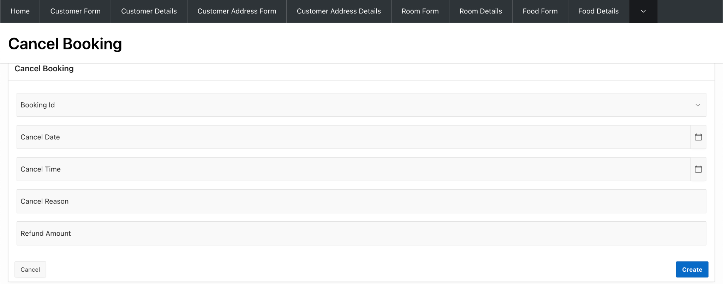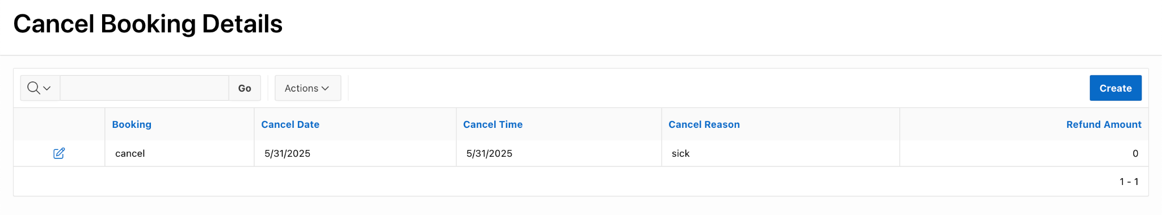

4.14- Cancel Booking Form & Details

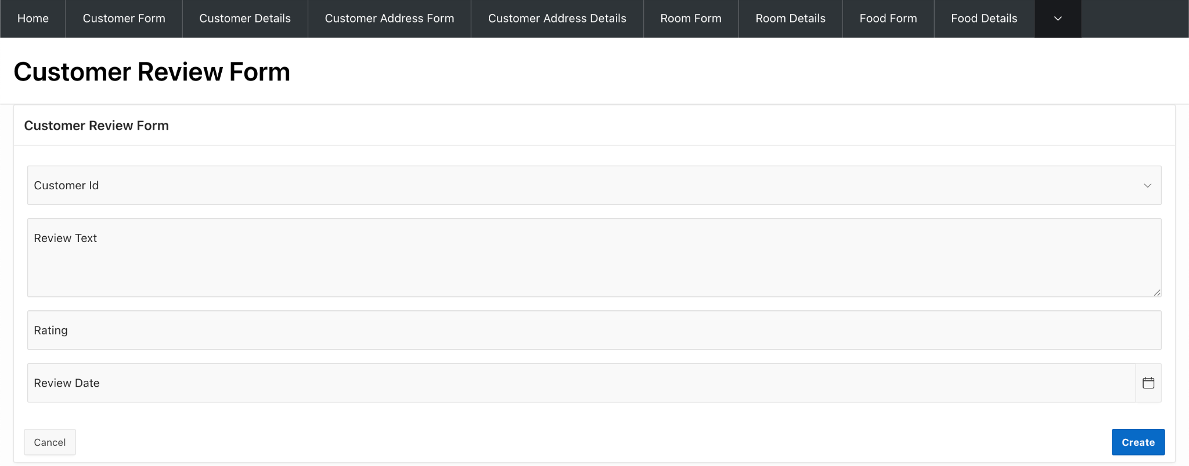

4.15- Customer Review Form

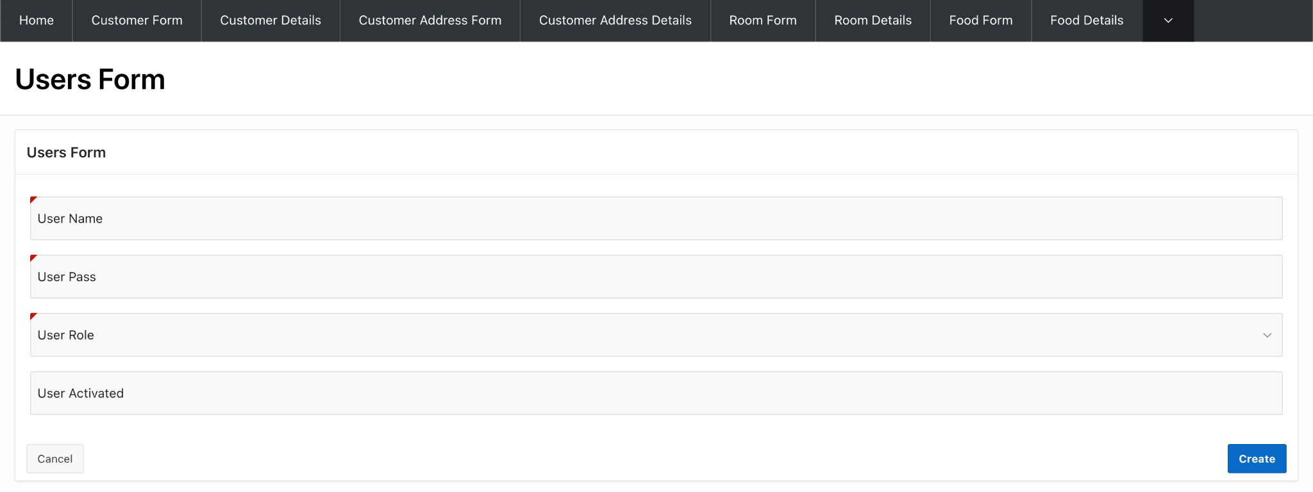

4.16 User Form

1. **Reports based on Multi-Table and Aggregate Queries**

|  |  |  |
| --- | --- | --- |
| **Page Number and Name** | **Query Type** | **Report description** |
| Page-54 & Top_Selling_Foods | Multi-table + Aggregate | Calculates total food quantity and price with showing food name |
| Page-73 & customer_contact_info | Multi-table | Shows customer information only |
| Page-74 & Room_Booking_History | Multi-table | Shows each customers booking details |
| Page-75 &  Maintenance_Log_View | Multi-table | Maintenance request details, customer details, room details |
| Page-80 &  Staff_Department_View | Multi-table | Shows staff members along with their department and role. |

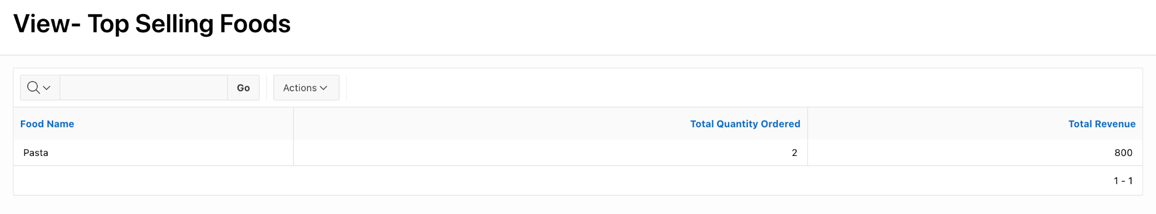

6.1-Top_Selling_Foods

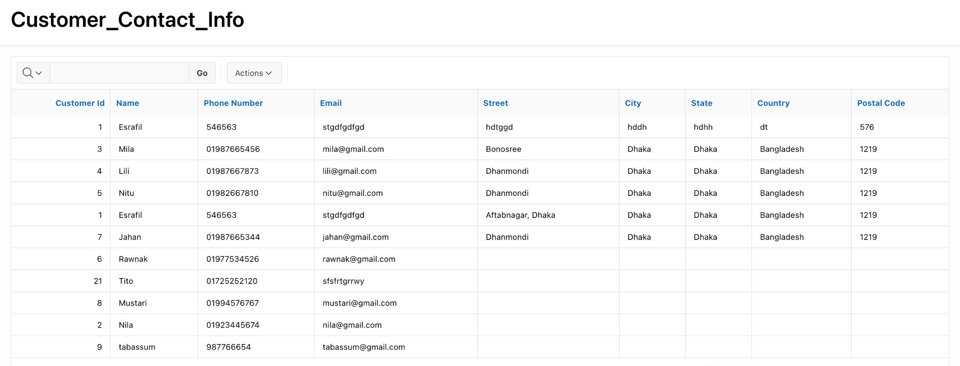

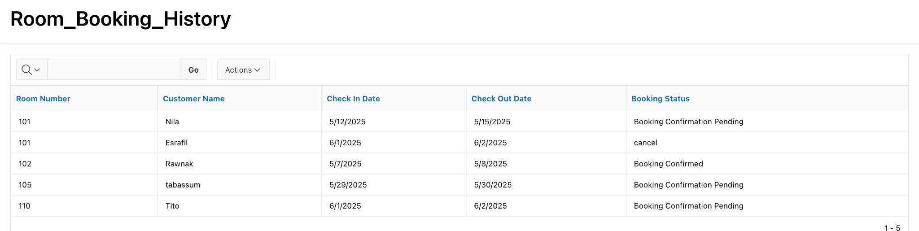6.2-customer_contact_info

6.3-Room_Booking_History

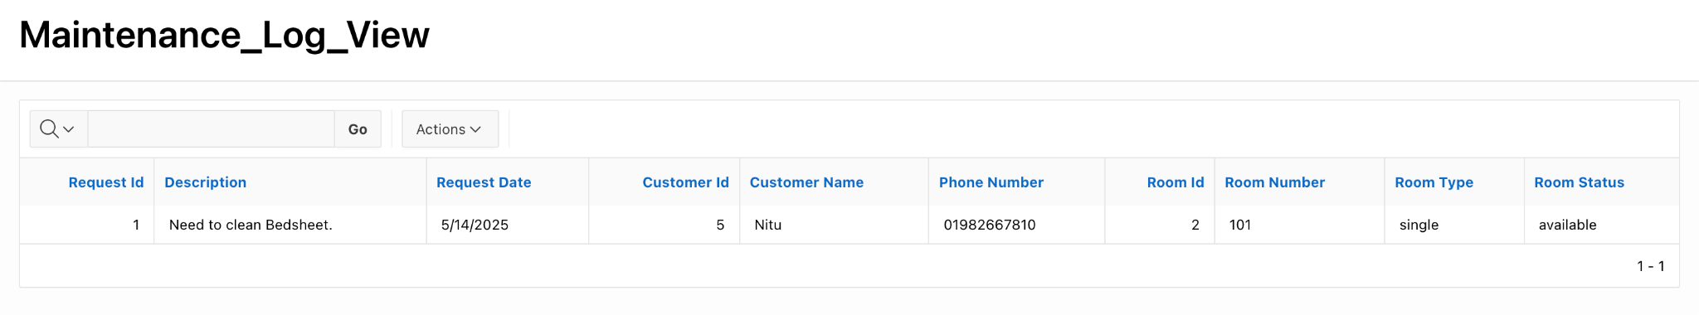

6.4-Maintenance_Log_View

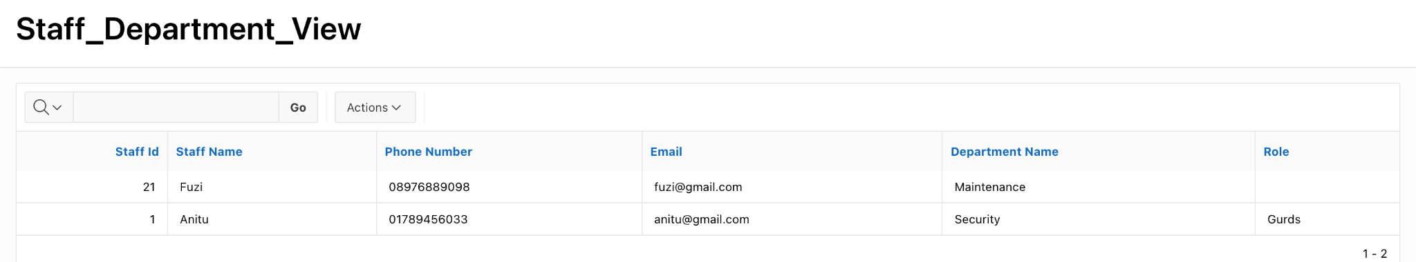

6.5-Staff_Department_View

1. **Concluding Remarks**

Working on the Hotel Management System project gave us a clear understanding of how database management concepts are applied in real-world situations. Throughout the development process, we gained practical experience in designing e-r model, schema design, tables, writing SQL queries, managing relationships between entities, and maintaining data integrity. It helped us see how a well-organized database can make tasks like room booking, customer check-in/check-out, staff management, and billing much more efficient.

This project not only helped us strengthen our technical knowledge in DBMS but also taught us the importance of collaboration and planning in system development. It was a great opportunity to turn theoretical knowledge into a practical solution. We believe the system we built has a solid foundation and can be expanded further with features like online booking, customer feedback, and reporting tools.